 <https://www.understood.org/~/media/040bfb1894284d019bf78ac01a5f1513.pdf>



<https://developingchild.harvard.edu/science/key-concepts/executive-function/>

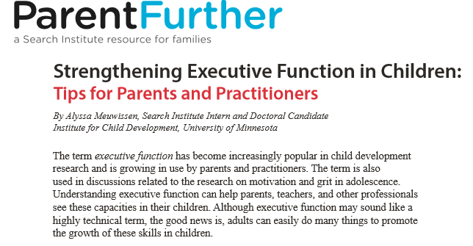

<http://www.search-institute.org/downloadable/exec-function-feb-2015.pdf>

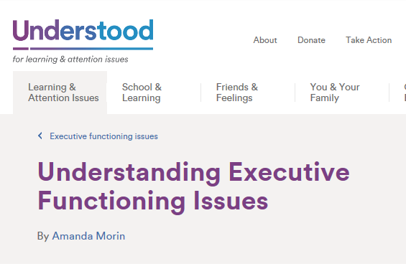

<https://www.understood.org/en/learning-attention-issues/child-learning-disabilities/executive-functioning-issues/understanding-executive-functioning-issues>



<https://www.huffingtonpost.com/ellen-galinsky/executive-function-skills_b_1412508.html>

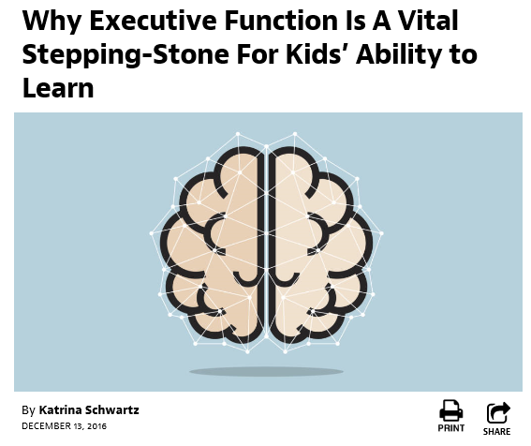

<https://ww2.kqed.org/mindshift/2016/12/13/why-executive-function-is-a-vital-stepping-stone-for-kids-ability-to-learn/>



<https://education.cu-portland.edu/blog/curriculum-instruction/executive-functioning-strategies-for-children-to-thrive-school/>



<http://hechingerreport.org/new-research-finds-magic-8-preschool-classroom-practices/>