

**LETRS Information**

**Each Unit is worth 1.5 CEUs, 10 SEMis or 1 OSL**

**You must complete the Voyager Sopris Modules and receive this certificate for each Unit**

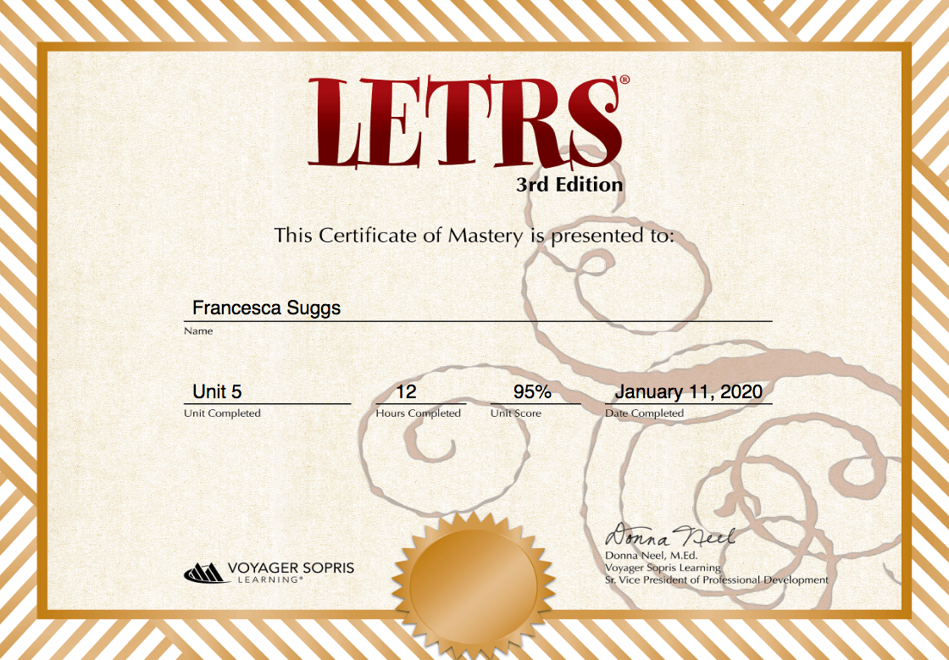

**After you have completed the modules and your zoom meeting you will complete the CEU application by clicking on this link:**

[**https://www.northmsec.com/mde-office-of-elementary-education-and-reading/**](https://www.northmsec.com/mde-office-of-elementary-education-and-reading/)

**If you have questions regarding your books and the online modules please email LeighAnne Cheeseman at MDE** [**lcheeseman@mdek12.org**](mailto:lcheeseman@mdek12.org)

**Questions regarding CEUs/credits Email Anna Brantley:** [**Brantley@olemiss.edu**](mailto:brantley@olemiss.edu)