**Product Key Activation**

***If you already have a Teachstone account****, please login and you will see a blue tab on the left hand side of your account home screen (Your Dashboard) that reads "Activate A Product Key".   Click on this tab, input the key, and submit.  Once this is done you will have a new Online Course tile on your Dashboard (you may have to refresh your page to see this if it does not automatically populate).  Click on this tile and you will then see a link that will lead you into the course.*

***Please make sure there are no spaces before or after the product key when activating, or the system will not recognize the key.***

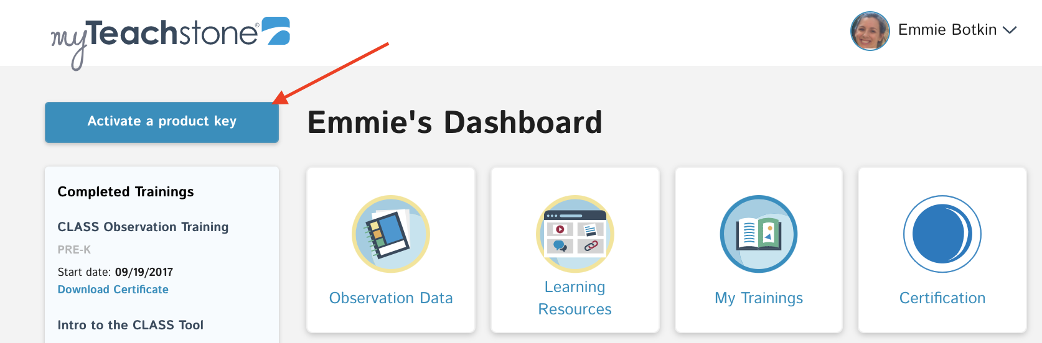

***If you do NOT have a Teachstone account****you will be able to create an account with the use of this key. First, please go to our*[*Login Page*](https://dashboard.teachstone.com/users/login)*.*

|  |  |
| --- | --- |
|  |  |

*Click on the blue Activate $a product key tab. You will submit your key and complete the setup steps for your account. Once this is finished, you will be on your home account page - your Dashboard. You will see the Online Course tile which you will click on to gain access to the course.*

**Interactions at the Heart of Healing, Online Course Product Key**: **9GWF5227TZ92CQQ4**