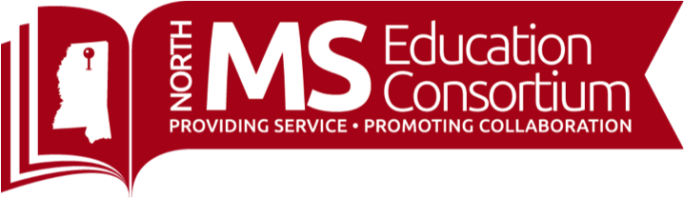

**UPCOMING EVENTS**

**TRADITIONAL COURSES**

**October**

* **October 14:** [School Leadership with Dr. Todd Whitaker (Virtual 8:30AM-11:30AM)](https://nmec.msresaservices.com/SL-todd-whitaker-fall)
* **October 16 & 23:** [Active Family, Community, School Partnerships in Response to Covid-19 (Virtual)](http://nmec.msresaservices.com/fcsp-covid-oct16)
* **October 19-20**: [Social and Emotional Learning as A Key Component in Response To Covid-19](https://nmec.msresaservices.com/SEL.1920)
* **October 22, November 12, 2020, January 14, February 11, March 16, and April 8, 2021:** [2020-2021 Leadership Skills Development Academy](https://nmec.msresaservices.com/LSDA-2021)
* **October 23**: [From All to Each and Every: Resources and Practices for Supporting Children of Diverse Cultures, Languages, and Abilities and their Families (10AM-12PM](http://nmec.msresaservices.com/from-all-to-each-and-every)
* **October 27-28**: [Social and Emotional Learning as A Key Component in Response To Covid-19](https://nmec.msresaservices.com/SEL.2728)

**Regional Literacy Training for K-3 Teachers (LETRS) - 3rd Edition Units 1-8**

Please contact LeighAnne Cheeseman for registration: [lcheeseman@mdek12.org](mailto:lcheeseman@mdek12.org)

**Teacher Tip Tuesday: Join us every Tuesday at 3:30!**

<https://www.northmsec.com/teachertiptuesday/>

**October/November Topics and Instructors**

**October 20:** Creating and Using a Bitmoji Classroom, Mr. Tammy Kirkland

**October 27:** How to Use Flipgrid to Engage Students in Virtual Learning, Dr. Sara Platt

**November 3**: Building Community and Collaborative Learning With Google Slides, Joel Amidon