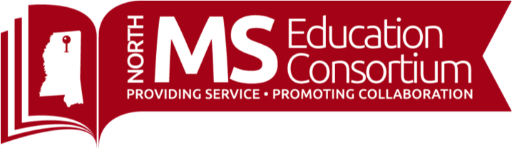

**UPCOMING EVENTS**

**TRADITIONAL COURSES**

**November**

* **October 29-30**: Annual McKinney-Vento/Homeless Training

**November**

* **November 5 & 10**: Active Family, Community, School Partnerships in Response to Covid-19
* **November 9 & 11**: Social and Emotional Learning as A Key Component in Response To Covid-19

**January**

* **January 10**: Improve Your Team’s Performance for Athletic Directors and Coaches

**February 9**

* **February 9**: Improve Your Team’s Performance for School Leaders

**Regional Literacy Training for K-3 Teachers (LETRS) - 3rd Edition Units 1-8**

Please contact LeighAnne Cheeseman for registration: [lcheeseman@mdek12.org](mailto:lcheeseman@mdek12.org)

**Phonics First® (K-5th) Orton-Gillingham (Self-paced)**

* **November 1, 2020**
* **November 15, 2020**
* **December 1, 2020**

**Phonics First® (K-5th) Orton-Gillingham Refresh Course (Self-paced)**

* **November 1, 2020**
* **November 15, 2020**
* **December 1, 2020**

**Level II Phonics First® (K-5th) Orton-Gillingham**

* **December 7-11, 2020**

**Teacher Tip Tuesday: Join us every Tuesday at 3:30!**

<https://www.northmsec.com/teachertiptuesday/>

**October/November/December Topics and Instructors**

**October 27:** How to Use Flipgrid To Engage Students in Virtual Learning with Dr. Sara Platt

**November 3**: Building Community and Collaborative Learning With Google Slides, Joel Amidon

**November 10:** TBD

**November 17:** TBD

**December 1**: Movement Matters! Effectively Integrating Movement into the Elementary Classroom (F2F and Virtually), Dr. Alicia Stapp and Ms. Tess Johnson

**December 8**: National Board Certification, Joel Tammy Kirkland