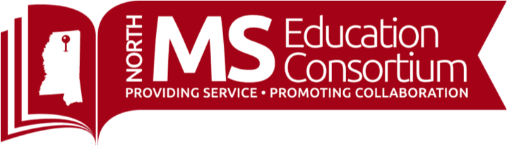

**UPCOMING EVENTS**

**TRADITIONAL COURSES**

**October**

* **October 8, 22, 29:** Special Education In Times like These
* **October 12:** Trauma-informed Instruction: What Teachers Need to Know (Face to Face)
* **October 12-13:** New Directors Overview of EDGAR
* **October 13 & 15:** Trauma-informed Instruction: What Teachers Need to Know (Virtual 12-3:30)
* **October 14:** School Leadership with Dr. Todd Whitaker (Virtual 8:30AM-11:30AM)
* **October 16 & 23:** Active Family, Community, School Partnerships in Response to Covid-19 (Virtual)
* **October 19-20**: Social and Emotional Learning as A Key Component in Response To Covid-19
* **October 22, November 12, 2020, January 14, February 11, March 16, and April 8, 2021:** 2020-2021 Leadership Skills Development Academy
* **October 23**: From All to Each and Every: Resources and Practices for Supporting Children of Diverse Cultures, Languages, and Abilities and their Families (10AM-12PM
* **October 27-28**: Social and Emotional Learning as A Key Component in Response To Covid-19

**Regional Literacy Training for K-3 Teachers (LETRS) - 3rd Edition Units 1-8**

Please contact LeighAnne Cheeseman for registration: [lcheeseman@mdek12.org](mailto:lcheeseman@mdek12.org)

**Teacher Tip Tuesday: Join us every Tuesday at 3:30!**

<https://www.northmsec.com/teachertiptuesday/>

**September/October Topics and Instructors**

**October 6:** Enhance Mathematics Learning and Enthusiasm Virtually, Dean Rock, University of MS

**October 13:** Monitoring Small Group Discussions in a Virtual Setting, Ms. Elise Brown

**October 20:** Creating and Using a Bitmoji Classroom, Mr. Tammy Kirkland

**October 27:** How to Use Flipgrid to Engage Students in Virtual Learning, Dr. Sara Platt

**November 3**: Building Community and Collaborative Learning With Google Slides, Joel Amidon