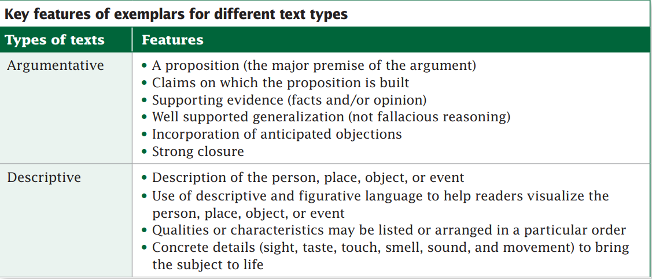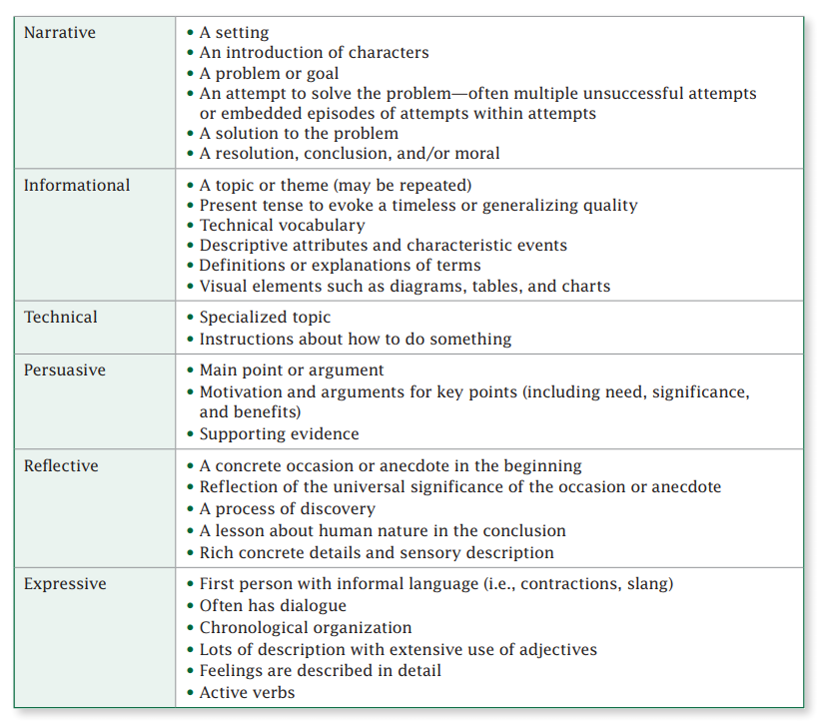

Scaffolding Revision

**(Marking Text for Self-Review of Student Paragraphs)**

1. Underline the topic sentence of your paragraph.
2. Circle transitional words and phrases and review comma usage in conjunction with these words and phrases.
3. Number any evidence statements or major points that support your main idea.
4. Place a box around any pronouns that you use.
5. Count the number of times that you use the pronoun ‘you’ and any pronoun where you refer to yourself (I, me, my, mine, myself, etc.)
6. Underline your conclusion.

Once complete, have students review the results of the independent review. Have students ensure that there is a clear topic sentence and conclusion of the paragraph. Make certain that transitional words and phrases as well as any corresponding punctuation marks are used correctly. Check for correct usage of pronoun antecedents, and keep in mind how often pronouns are used, particularly those referring to an unknown ‘you’ and pronouns referring to yourself. Look for precision in language/word choice for verbs, nouns, and descriptive words. Look for consistency in voice.

Once the self-review is complete, trade paragraphs with your partner and follow the same review process.

**Sample paragraph for Scaffolding Revision:**

**Expectations for women in the work place should be reasonable so that women can successfully manage family and work place responsibilities. Although flexibility may be "officially" extended at work, including leave for birth of a child or the ability to work from home when necessary, the culture of the workplace may be such that it is expected that a woman would not take advantage of these. For example, Marissa Mayer was recently hired as the president of Yahoo. She is pregnant and intends on taking only a brief time of leave when she has her baby. In fact, she says she will be working from home very soon afterward. This is unrealistic for most women and should not be the expectation. If women perform well at work, they must be assured that they will be afforded the flexibility to take care of their families.**

**Takeaways on scoring:**

* Use or develop rubrics, teach students how to self-assess, and teach to the highest score on the rubric.
* Establish practice/anchor sets and provide a mini-training so that others can also recognize papers that score at all levels (focus on developing the “lines” between rubric points. Occasionally, pull a sample of student responses and evaluate them together to avoid “scoring drift.”
* Provide plenty of time for students to write and provide them with feedback so they can continually improve the quality of their writing.