**MS CEC Board**

**Jennifer Boykin, Past President**

Jennifer L. Boykin, Ed. D. is Project Manager and Special Supports Lead for Bailey Education Group where her areas of expertise include special education, social emotional learning, Multitiered Systems of Support (MTSS), classroom management and behavior, policy and procedure, and early childhood. In addition, she is Assistant Professor of Education at William Carey University where she teaches graduate level education courses and supervises alternate route interns in the field. Having served in public education for 17 years, she began her career as a special education teacher for elementary students with moderate to severe disabilities and has taught students with mild to moderate disabilities at the middle school level. She began her educational leadership experience as Special Education Case Manager and Section 504 Coordinator. She has served as Director of Special Services for Pearl Public School District for 6 years. She earned her Bachelor of Arts in Education from Millsaps College and her Specialist and Doctorate in Education from William Carey University. She values involvement in vocational organizations as a vehicle for continuous professional improvement. As such, she currently serves as President for the Mississippi Council for Exceptional Children and President Emeritus of the Mississippi Council for Administrators of Special Education (MS-CASE). She is a member of Crossgates Baptist Church where she is a member of the Crossgates Praise Team and Worship Choir. She lives in Pearl, Mississippi with her husband, Justin, and their two children.

**Julie Etheridge, President**

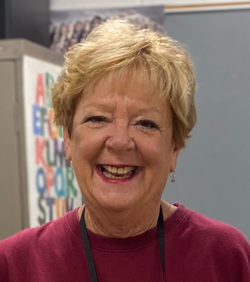Julie Etheridge is the Director of Special Services for the Walthall County School District in Tylertown Mississippi. She earned a bachelor’s degree in special education, mild/moderate disabilities from University of Southern Mississippi in December of 1991 with 12 emphasis hours through the University Affiliated Programs (now the Institute for Disabilities Studies) in early intervention. Julie began working in January 1992 for the Covington County School District where she planned and implemented the special education preschool program for the county and then served as the teacher of the first Developmentally Delayed classroom at Collins Elementary School. She earned her Master’s degree from USM in special education, severe/profound disabilities in 1992, and began her career in the Walthall County School District in 1993. Julie served as a special education teacher for community-based preschool, homebound/hospital, and first grade resource and self-contained. She served as Case Manager for Special Services before earning administrator licensure and becoming Director of Special Services in 2012.

Julie currently serves in her community as a Youth Intervention Court team member and a Coalition for Healthy Adolescent Programs and Services (CHAPS) team member and former president. She is a member of Mississippi Professional Educators (MPE) and the Council of Administrators of Special Education (CASE). Additionally, she is currently serving on the Special Education Teacher Shortages Workgroup partnering with MDE, CEEDAR, and other directors across the state to support the retention and recruitment of quality special education teachers in Mississippi.

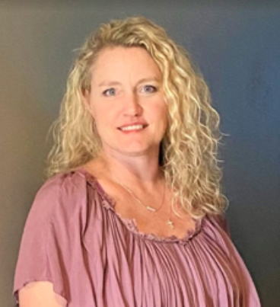**Michelle McClain, President-Elect**

Michelle McClain is currently the Behavior Intervention Specialist for Intervention Services in the Office of Elementary Education and Reading at the MS Department of Education. Prior to this school year, she served as Behavior Support Specialist at Pearl Public School District for Special Services grades K-8. In that position, Michelle developed Functional Behavioral Assessments and Behavior Intervention Plans, provided training to faculty, staff, and parents on implementation of the BIP, and provided services and supports to students with an Individualized Education Plan. Michelle’s tasks also included providing behavioral supports to students with sensory regulation/stimulation needs, for Social Emotional Learning Skills, and supports for students in alternative school placement. For the 20/21 school year, she provided academic services virtually to K-12th grade self-contained students. Michelle spent five years as a self-contained special education teacher at Upper Elementary. She then taught the alternative school/behavior classroom students K-12 for Pearl Public School District. Michelle presented in one of the concurrent sessions at the 2019 CEC Team Up to Build Up Fall Conference in Hattiesburg. Michelle received her Education Specialist Degree in Emotional Behavioral Disorder from William Carey University in November 2019, Master’s Degree in Elementary Education from Delta State University in 2010, and Bachelor’s Degree in Special Education from the University of Southern Mississippi in 2005. Working with autistic students and students with an Emotional Behavioral Disorder has become her passion for teaching. She believes that while not all students will take that adventure to college; it is her hope with the knowledge she gives them, they will be successful in life.

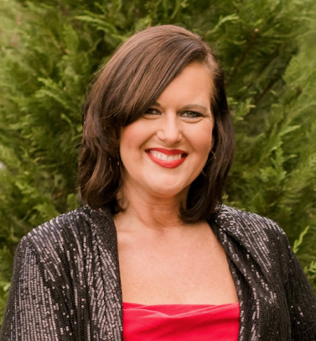**Allison “Paige” Pigott, Vice-President**

Allison “Paige” Pigott is a 1997 graduate from Mississippi State University with a Bachelor’s degree and a 2018 graduate a Master’s degree in Educational Leadership and is near completion of a Specialist degree in Instructional Leadership from William Carey University. Ms. Pigott has a total of 22 years experience in special education which includes experience in cross-categorical disabilities and services throughout the continuum of placement options in urban and rural settings.

Ms. Pigott’s education experience includes thirteen years as a teacher, two years as a Behavior Interventionist, and seven years in administrative roles within special education. Ms. Pigott began her teaching career in 1998 at Bogalusa High School in Bogalusa, Louisiana. Ms. Pigott shifted to teaching students with significant cognitive disabilities (SCD) at Baldwin High School while living in Milledgeville, Georgia. Later in 2003 Ms. Pigott relocated to the Baton Rouge, Louisiana area and taught specialized programs for students with autism for the East Baton Rouge Parish school system.

Ms. Pigott opted for a shorter work commute and accepted a teaching position in the Zachary Community School District (ZCSD) in Zachary, LA teaching students with SCD. In Zachary, Ms. Pigott further her teaching craft by pursuing extensive training from the University of North Carolina in TEACCH. Ms. Pigott implemented the program in her classroom and later shifted to the district Behavior Interventionist and Instructional Support Specialist for the ZCSD for students with SCD. In this role, Ms. Pigott trained teachers in center based learning with the implementation of TEACCH and modified the program to fit a classroom model into the Zachary Structured Teaching Program (Z-STP). The program was implemented in all classrooms serving students with SCD in the school district. In addition, Ms. Pigott developed district policies and procedures for Response to Intervention (RTI) for behavior and ensured the provision of those services. Next, Ms. Pigott shifted roles again to gain more experience in total inclusion settings and school improvement by accepting a position with Plaquemines Parish School District at South Plaquemines Parish High School and relocating to Buris, LA. After assisting in moving the school from a C rated school to an A rated school Ms. Pigott returned to her home state of MS.

Ms. Pigott began work with the Mississippi Department of Education in the Office of Special Education (OSE) as a compliance monitor. In this role, Ms. Pigott assisted in accreditation audits and cyclical monitoring of implementation of state policies for students with disabilities. Later Ms. Pigott shifted roles as an Instructional Support Specialist for OSE and conducted training on various special education topics, assisted with the Alternate Diploma rollout, and the development of the new MS-Alternate Academic Achievement Standards. Ms. Pigott has served as a school district Special Services/Education Director for a total of nearly five years. She served as a Special Education Director and MSIS primary for the MS Schools for the Deaf and the Blind in Jackson, MS and is currently the Special Services Director for the North Pike School District located in Summit, MS. At North Pike Ms. Pigott is the administrator in charge of Special Education and Gifted programing, Section 504, and serves as the district’s MSIS secondary.

**Carol Ann Franklin, Treasurer**

Carol Ann Franklin presently teaches special education in the Clinton Public School District where she has been employed since 1975. She received her undergraduate degree from Mississippi State University in 1975, and her Master’s degree from Mississippi State in 1978.  She earned National Board Certification in the area of Exceptional Needs in 2000. She was recognized as Teacher of the Year at Clinton Junior High School in 2003, 2015, and 2021. Carol Ann has been a member of CEC for numerous years and has held the office of treasurer for the past sixteen years. She is the recipient of the Mississippi CEC Teacher of the Year for 2022.

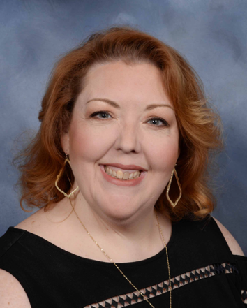**Gretchen Cagle, Secretary**

Gretchen Cagle is the Special Education Director for Rankin County School District. Previously, she served as the Special Education Head Coach for Bailey Education Group. She has 25 years of experience in the field of special education including serving as the State Director of Special Education for the Mississippi Department of Education.  She began her career teaching students with significant disabilities at Hudspeth Regional Center in Whitfield. She attended the acclaimed Peabody College at Vanderbilt University in Nashville where she worked as a graduate assistant and research assistant on a Peer Buddy research project and was published as a result of her contributions to the project. Upon completion of her master's degree in special education for students with severe disabilities, she worked in the field of assistive technology and augmentative communication as the regional representative for the Prentke Romich company and as the Assistive Technology Unit (ATU) Facilitator at Hudspeth Regional Center. She left Hudspeth's ATU to become the director of training for Parent Partners, a non-profit organization that oversaw the parent training and information center grant from the U.S. Department of Education's Office of Special Education Programs. There she worked with parents of students with disabilities, training on the principles of the Individuals with Disabilities Education Act (IDEA) and advocacy techniques to use in working with school districts. During this time, she completed coursework to obtain a license in psychometry and went to work for the Rankin County School District as assistant director of special education. Her duties included working with the statewide assessment system, running the extended school year program, conflict resolution, and a variety of other administrative functions. After eight years with Rankin County, she was selected as an Educator in Residence in the Office of Student Assessment at Mississippi Department of Education prior to her appointment as State Director of Special Education.

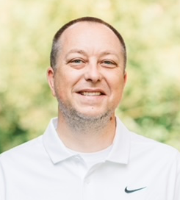**Bobby Richardson, CEC Divisions Coordinator/CAN Coordinator**

Bobby L. Richardson is the Director of IDEA Fiscal Supports and Special Projects in the Office of Special Education at the Mississippi Department of Education. In his current role, he provides professional development, technical assistance, and coaching to special education directors and teachers around allowable use of funds, IDEA funding applications, alternate diploma, and assists with the implementation of the fiscal monitoring procedures and protocols. Bobby has a master’s degree in Education Leadership and Administration and serves on the Board of Directors for the Mississippi Council for Exceptional Children (MS CEC). He is a member of the Council for Chief State School Officers (CCSSO) – Assessment, Standards, & Education for Students with Disabilities (ASES) Steering Committee, and Mississippi Professional Educators (MPE). Bobby is actively involved in the National Center for Systemic Improvement (NCSI) Collaboratives, the Collaboration for Effective Educator Development, Accountability, & Reform (CEEDAR) Teaching and Leading Solutions Group (TLSG) – Educator Recruitment and Retention, and the National Center on Educational Outcomes (NCEO) 1% Community of Practice Workgroup. Mr. Richardson has twenty-two years of experience educating and advocating for today’s youth through service as a general education teacher, a special education teacher, and through his work at the State Department of Education.

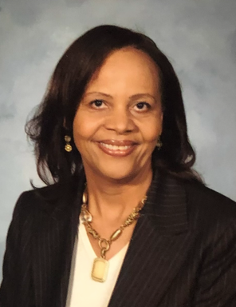**Debbie Hubbert, Membership, Grants and Awards Coordinator**

Mrs. Hubbert earned her Master of Education from Georgia State University, Atlanta, GA. She received certifications in numerous areas of Special Education in the state of Georgia, Ohio, and Mississippi. She received her Bachelor’s degree from the University of Alabama, Tuscaloosa, AL. As a Special Education teacher, she has proven her skills in the classroom as a valuable instructor; her success is evident in the repeated progress she accomplishes in working with children of various rulings